**Question E**

**Mosfet Selection**

It is known that switching element must be withstand the maximum input voltage and the secondary voltage reflected value. On the other hand, spikes which are caused by leakage inductances should be considered. MOSFET VDS can be calculated from below formula: [1]

$$V_{DS}= \left[{(V}_{IN(max)}+V_{L})+(\frac{Np}{Ns})×(V_{O}+V_{D})\right] ×1.3$$

Where;

$$V_{DS}=Drain to source voltage of MOSFET$$

$V_{L}=Voltage spike due to leakage inductance of transformer,$*estimated to be thirty percent of the $V_{IN(max)}.$*

1.3 additional safety factor

$$V_{DS}= \left[18+18x0.3)+(\frac{1}{7})×(48+1.2)\right] ×1.3$$

$$V_{DS}= \left[18+18x0.3)+(\frac{1}{7})×(48+1.2)\right] ×1.3$$

$$V_{DS}=39.55 V$$

In order to be simulate more realistic, only the MOSFET's in the LTspice library are searched.

Si7852DP with VGS=80V and ID=6.1 A is chosen. It has low RDSon (16 mΩ)

**Snubber Design**

Snubber design should be made otherwise voltage spikes may cause MOSFET breakdown. [2]

Maximum snubber capacitor voltage ripple is arranged as 10%.

$$V_{C(max)}=V_{DS(max)}× 0.1+\frac{D_{MAX}}{{1-D}_{MAX}}×V_{IN(min)}=39.55× 0.1+\frac{0.4}{1-0.4}×12 V=11.95 V$$

Power in the snubber resistor can be estimated as follows:

$$P_{RSNUBBER}=\frac{{I_{PPEAK}}^{2}×L_{LEAK}×f_{SW}}{2}=\frac{{13.9}^{2}×1.93 uH×100kHz}{2}=18.64 W$$

$$R_{SNUBBER}=\frac{{V_{CMAX}}^{2}}{P_{RSNUBBER}}=7.66 Ω$$

$$C_{SNUBBER}=\frac{1}{∆VC×R_{SNUBBER}×fsw}=\frac{1}{10\%×7.66×100k}=13.05 μF$$

**Circuit Simulation with Non Ideal Elements**

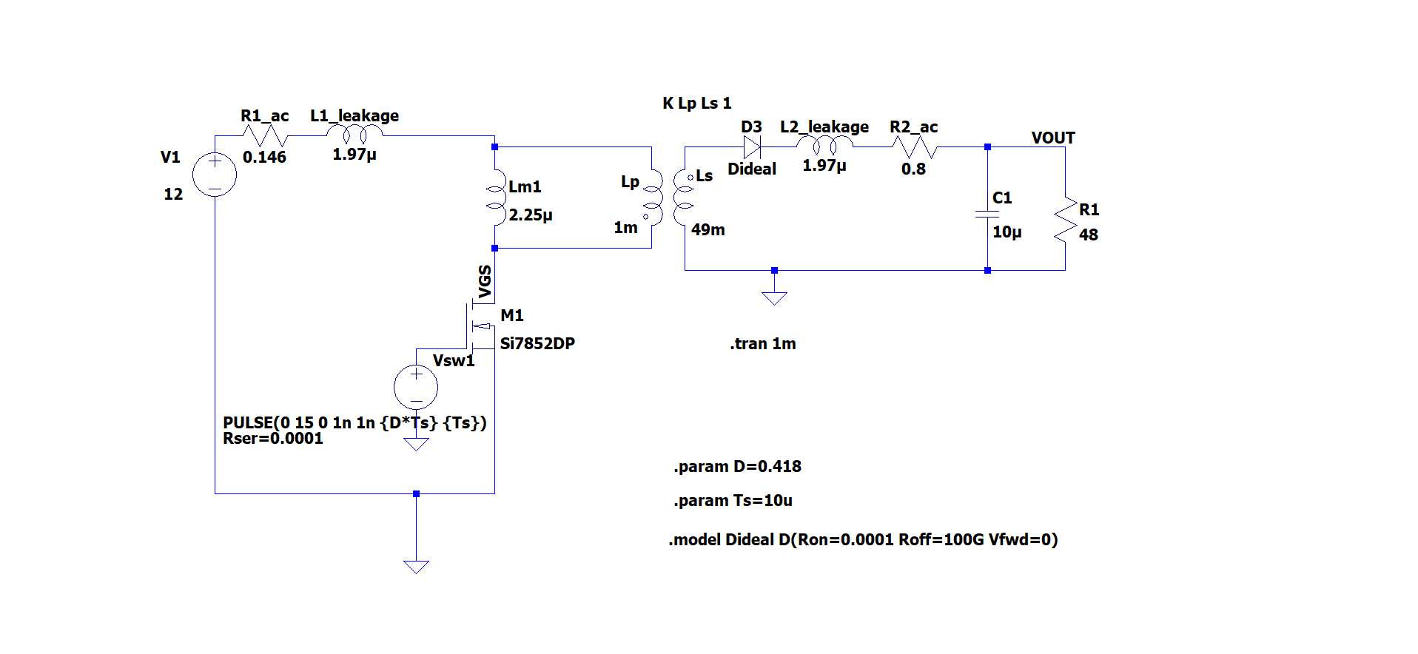

**VDS Voltage Without Snubber**

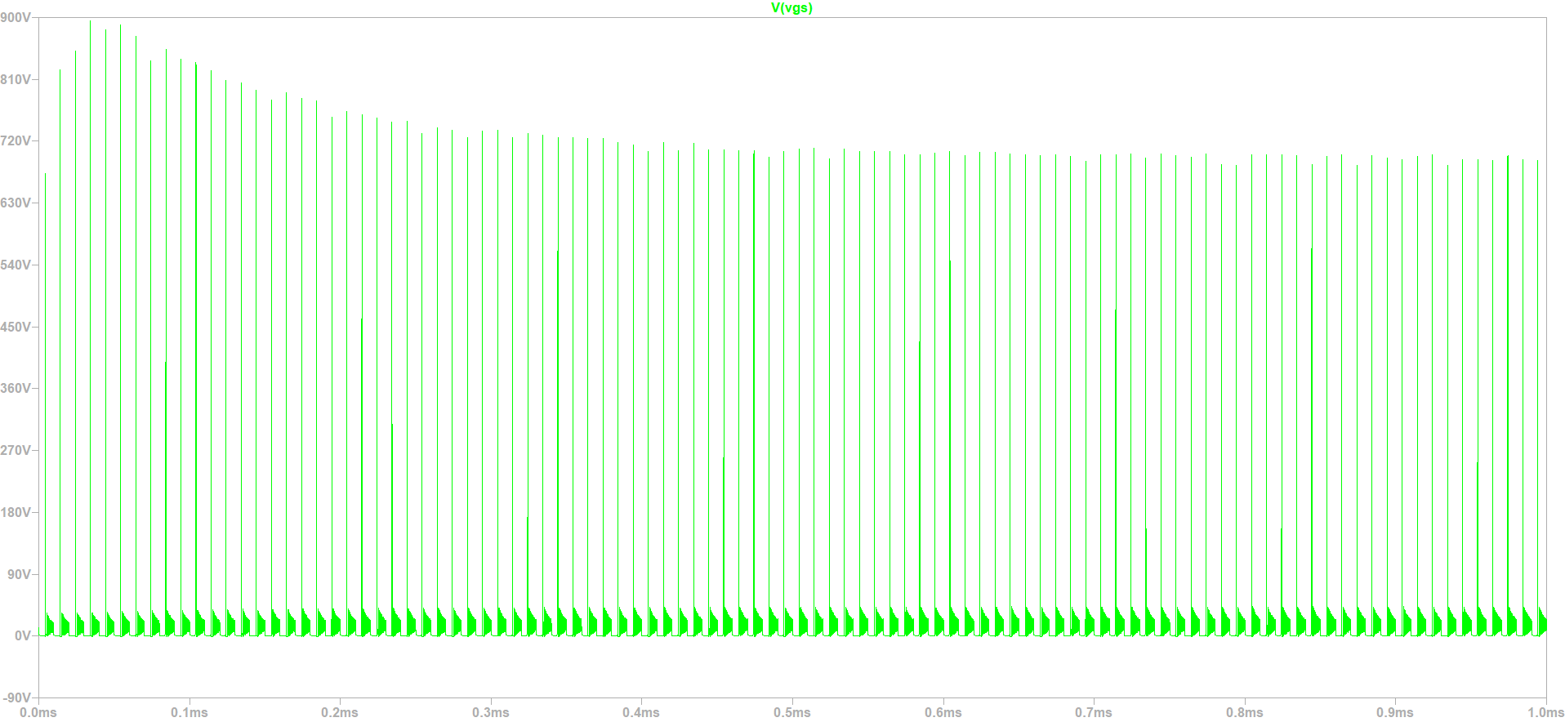

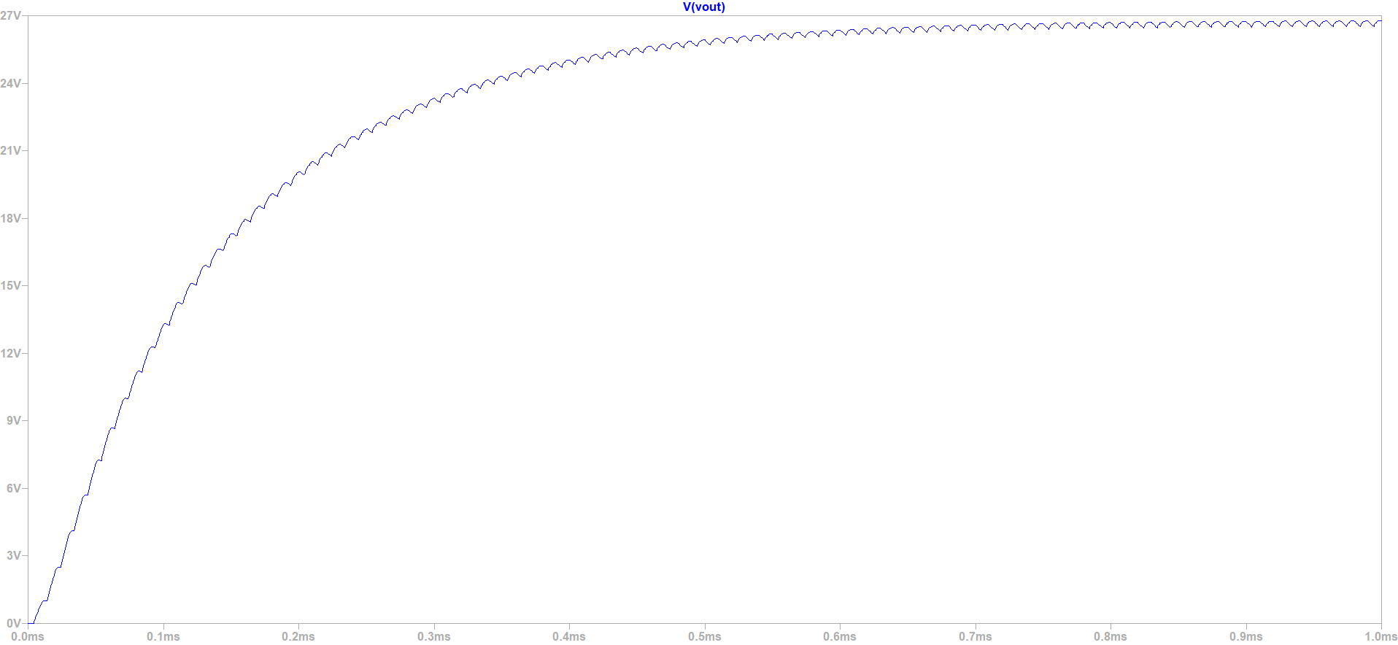

**VDS voltage with snubber**

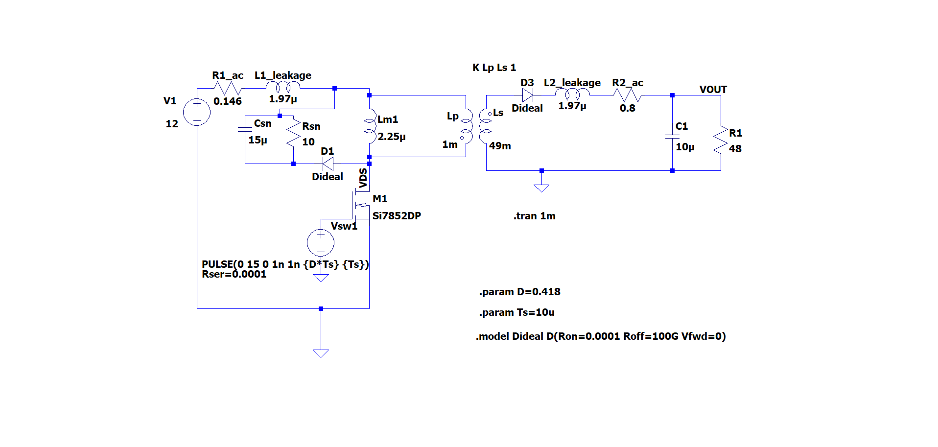

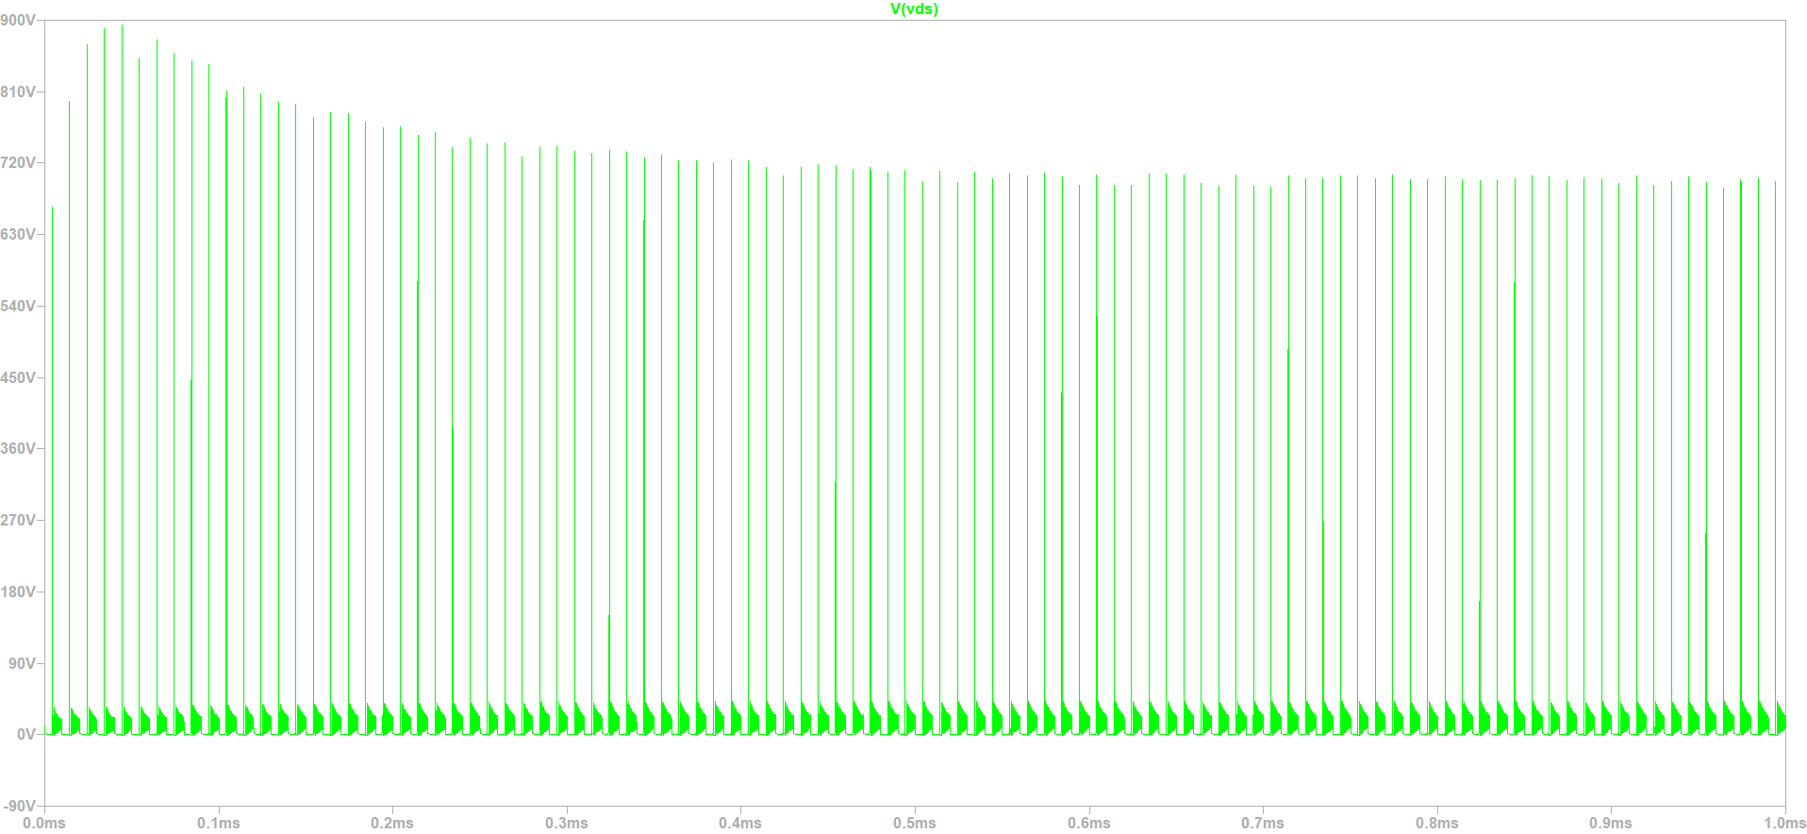

Circuit simulations has done again with assuming lower leakage inductance.

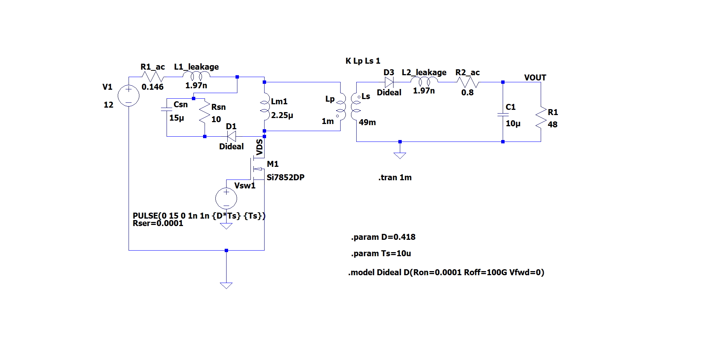

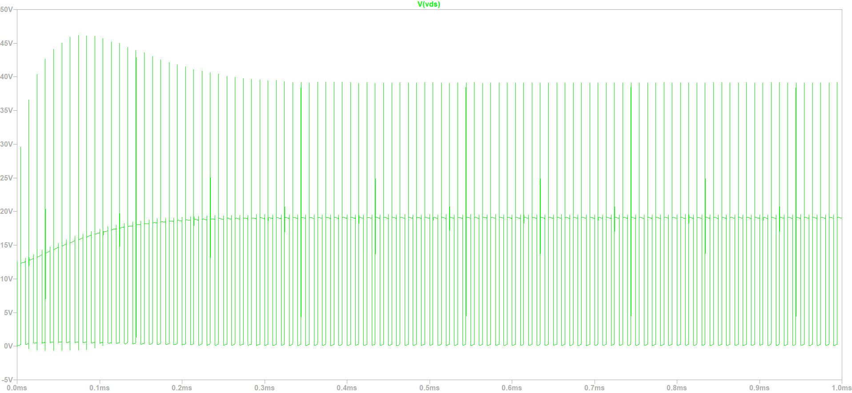

VDS (Drain to source) voltage is now reasonable value.

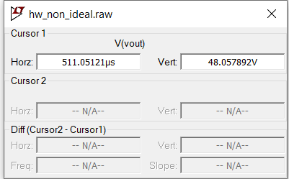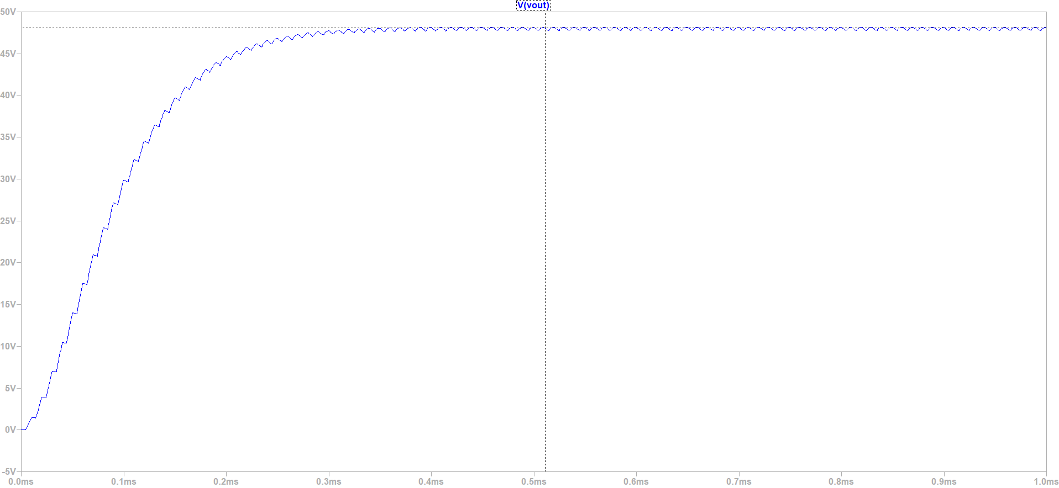

In order to get output voltage of 48 V duty cycle is set to a little bit higher than 0.4. The reason for that is non-idealities of the components. In order to be more safe the turns ratio should be considered again.

**Question F**

**%100 load:**

* **Losses of the transformer**

**Copper Losses**

$$I_{sw(max)}= \frac{1}{1-D}Iin+\frac{1-D}{2_{Lm}f}\frac{N1}{N2}xV_{o}=13.9 A$$

$$I_{1(rms)}= \sqrt{{I_{sw(max)}}^{2}xD}=7.46 A$$

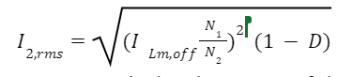

Copper losses are calculated as 1.26 W before.

$$P_{cu}=P_{cu1}+P_{cu2}=R1*{I_{1\left(rms\right)}}^{2}+R2*{I_{2\left(rms\right)}}^{2}=1.26 W$$

**Core Losses**

Core losses are calculated as 5.32 W before.



* **Losses of Mosfet**

**Mosfet Conduction Losses**

In the on state, MOSFETs do not behave like an ideal switch with zero impedance, instead MOSFETs have a small resistor called $R_{DSon}$. Due to this resistance, there are power losses in the mosfet and they are calculated as follows [3]:

$$P_{rDS}=R_{DSon}×{I_{Srms}}^{2}$$

$$P_{rDS}=16 m×{7.46}^{2}=0.89 W$$

**Mosfet Switching Losses**

In addition to the conduction losses, switching losses occur when the switches are opened and closed. Below figure shows the changes in the opening state and shows the changes in the closing state. In this case, the changes in voltage and current are assumed to be linear. The energy loss in a switching transition is the area under power. Since average power is energy divided by period, higher switching frequencies result in higher switching losses.

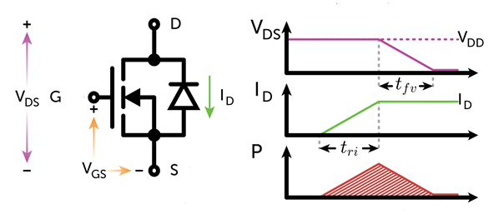

The $t_{ri}$ value represents the current rise time and the $t_{fv}$ value represents the voltage drop time on the graph in the trip state. Similarly, the value of $t_{fi}$ in the graph in the closing state represents the decrease time of the current, and the value of ${td}_{rv}$ refers to the decrease time of the voltage. The lost energy is found from the areas under the power graph and then the lost power is found by dividing it by the frequency.

$E_{on}=\frac{v_{ds}×id ×(t_{fv}+t_{ri)}}{2}$

$E_{off}=\frac{v_{ds}×id ×({td}_{rv}+t_{fi)}}{2}$

$P_{sw}=$ ( $E_{on}+E_{off})×f$ [3]

$$E_{on}=\frac{12×7.96×(18ns+26ns)}{2}=1.96×{10}^{-6}$$

$$E_{off}=\frac{12×7.96×(41ns+11ns)}{2}=2.48×{10}^{-6}$$

$P_{sw}=$ 0.444 W

* **Diode Losses**

Diode losses can be calculated from below formula.

$P_{C}=I_{D}×V_{D}+ r_{D}×{i_{Drms}}^{2}$ [4]

$$P_{C1}=I_{o}×V_{D}=1×0.83=0.83 W$$

$P_{C2}=R_{f}×{I_{Drms}}^{2}=66.18mΩ×1=0.66 mW$

$$P_{C}=0.84 W$$

* **Inductance Conduction Losses**

The following formula is given to find the inductance conduction losses:

Inductance conduction loss;

$P_{L}=r×{I_{Lrms}}^{2}$

The average value of the inductance current I_L is equal to the sum of the input current and output current. Therefore, the peak value of the switch current is reached.

$P_{L}=\frac{r×{I_{O}}^{2}}{{(1-D)}^{2}}$ [5]

$$P_{L}=\frac{0.146mΩ×1A}{{(1-0.4)}^{2}}=0.405 W$$

**Efficiency Calculation**

Total losses can be calculated as follows:

$P_{total}=1.26+5.32 +0.89+0.444+0.84+0.405=9.159 W$

Efficiency:

$η=\frac{Pout}{Pin}=\frac{Pout}{Ptotal+Pout}$

$$η=\frac{48}{9.159+48}=0.8397=\%83.97$$

**References**

**1.** Dinwoodie, L. (1999). Design Review: Isolated 50 Watt Flyback Converter Using the UCC3809 Primary Side Controller and the UC3965 Precision Reference and Error Amplifier. Texas Instruments. Retrieved May 1, 2023, from https://www.ti.com/lit/an/slua086/slua086.pdf

**2.**How to design a flyback converter in seven steps: Article: Mps. Article | MPS. (n.d.). Retrieved May 4, 2023, from https://www.monolithicpower.com/how-to-design-a-flyback-converter-in-seven-steps

**3**.(2012),*Small Signal OptiMOS™ 606 MOSFET in Low Power DC/DC converters,*(Application Note, AN 2012-12,), Retrieved from Infineon Technologies website:https://www.infineon.com/dgdl/Infineon-MOSFET_OptiMOS_606_Small_Signal_MOSFET_in_low_power_DC-DC_converters-AN-v01_00-EN.pdf?fileId=db3a30433c1a8752013c39eca58b4ae4

**4.** Lopez, M., Morales, D., Vannier, J.-C., & Sadarnac, D. (2007). Influence of Power Converter Losses Evaluation in the Sizing of a Hybrid Renewable Energy System. 2007 International Conference on Clean Electrical Power, Clean Electrical Power, 2007. ICCEP ’07. International Conference On, 249–254. <https://0-doi-org.divit.library.itu.edu.tr/10.1109/ICCEP.2007.384218>

**5.**Hairik, H. A., AbdulAbass, A. K., & Abbas, K. A. (2019). DC/DC Buck-Boost Converter Efficiency and Power Dissipation Calculation at Operating Points Not Included in the Datasheet. Journal of Multidisciplinary Engineering Science and Technology (JMEST), 6(6).